Terraform previous doc I have used to launch ec2 instance.
Then login to ssh neeraja@11.0.1.154 , pwsd : vpn
LIST INSTANCE IDs:
aws ec2 describe-instances \
--region ap-southeast-1 \
--filters "Name=tag:Name,Values=*dev*,*test*,*staging*,*uat*,*nonprod*,*non-prod*" \
--query "Reservations[].Instances[].InstanceId" \
--output text | tr '\t' '\n'
NAME OF SERVERS:
aws ec2 describe-instances \
--region ap-southeast-1 \
--filters "Name=tag:Name,Values=*dev*,*test*,*staging*,*uat*,*nonprod*,*non-prod*" \
--query "Reservations[].Instances[].Tags[?Key=='Name'].Value" \
--output text | tr '\t' '\n'
NAME + INSTANCE IDs:
aws ec2 describe-instances \
--region ap-southeast-1 \
--filters "Name=tag:Name,Values=*dev*,*test*,*staging*,*uat*,*nonprod*,*non-prod*" \
--query "Reservations[].Instances[].{Name:Tags[?Key=='Name']|[0].Value,ID:InstanceId}" \
--output table
Step-1: Connect to your EC2
From Windows PowerShell:
ssh -i "your-key.pem" ec2-user@<public-ip>
Step-2: Update system packages
sudo yum update -y
Step-3: Install dependencies
sudo yum install unzip curl -y

Step-4: Download AWS CLI v2
curl "https://awscli.amazonaws.com/awscli-exe-linux-x86_64.zip" -o "awscliv2.zip"
Step-5: Unzip installer
unzip awscliv2.zip
Step-6: Install AWS CLI
sudo ./aws/install --update
If asked replace, choose yes
Step-7: Verify installation
aws --version
Expected:
aws-cli/2.x.x Python/3.x ...
Optional Cleanup
Free up space after install:
rm -rf aws awscliv2.zip
Perfect — since you are on Amazon Linux, here is the correct and clean way to install Terraform on your new EC2.
Follow these commands step-by-step inside the instance 👇

Step-1: Install prerequisites
sudo yum install -y wget unzip

Step-2: Set Terraform version
T_VER="1.9.8"

Step-3: Download Terraform
wget https://releases.hashicorp.com/terraform/${T_VER}/terraform_${T_VER}_linux_amd64.zip

Step-4: Unzip
unzip terraform_${T_VER}_linux_amd64.zip
Step-5: Move binary to PATH
sudo mv terraform /usr/local/bin/
Step-6: Check version
terraform -version
Expected Output:
Terraform v1.9.8 (this version is stable no need of other verison)

Step-7 (Optional): Clean junk files
rm terraform_${T_VER}_linux_amd64.zip
Terraform is now installed & ready on your EC2 instance.
Correct Jenkins Installation for Amazon Linux 2
Install Java
sudo amazon-linux-extras install java-openjdk17 -y
sudo yum install java-17-amazon-corretto -y
echo 'JENKINS_JAVA_CMD="/usr/lib/jvm/java-17-amazon-corretto/bin/java"' | sudo tee /etc/sysconfig/Jenkins
sudo systemctl restart jenkins
sudo systemctl status Jenkins
optional -1. java -version
2.sudo journalctl -u jenkins -n 20 # to check last 20 error logs
Do this
sudo mkdir -p /var/log/jenkins
sudo chown -R jenkins:jenkins /var/lib/jenkins /var/cache/jenkins /var/log/Jenkins
sudo systemctl restart jenkins
sudo systemctl status jenkins
Add Jenkins repo
sudo wget -O /etc/yum.repos.d/jenkins.repo https://pkg.jenkins.io/redhat-stable/jenkins.repo
Import Jenkins key
sudo rpm --import https://pkg.jenkins.io/redhat-stable/jenkins.io.key
Install Jenkins
sudo yum install jenkins -y
Enable Jenkins
sudo systemctl enable jenkins
sudo systemctl start Jenkins
It means Jenkins did not install successfully, so the service file /usr/lib/systemd/system/jenkins.service doesn't exist yet.
cat /etc/os-release
sudo yum update -y 1to3 steps again and
Clear metadata & install Jenkins
sudo yum clean all
sudo yum install jenkins -y
Public key for jenkins ... is not installed
sudo yum clean all
sudo rpm --import https://pkg.jenkins.io/redhat-stable/jenkins.io.key
ls -l /etc/yum.repos.d/jenkins.repo #verisfy file exits see -rw-r—r—1
Fix Jenkins Key Issue & Install Jenkins (Amazon Linux 2)
1. Remove old Jenkins repo key
sudo rpm -qa gpg-pubkey* | grep jenkins | awk '{print $1}' | xargs -r sudo rpm -e
This clears any old/corrupted Jenkins key
2️⃣ Import latest Jenkins GPG key
sudo rpm --import https://pkg.jenkins.io/redhat-stable/jenkins.io-2023.key
If above fails, use legacy key (backup):
sudo rpm --import https://pkg.jenkins.io/redhat-stable/jenkins.io.key
3️⃣ Clean yum cache
sudo yum clean all
sudo yum makecache
4️⃣ Install dependencies
sudo yum install fontconfig -y
5️⃣ Install Jenkins
sudo yum install jenkins -y
If it fails again, run this instead:
sudo yum install jenkins -y --nogpgcheck
6️⃣ Enable & start Jenkins
sudo systemctl enable jenkins
sudo systemctl start jenkins
sudo systemctl status jenkins
You should see:
Active: active (running)
-- Access Jenkins UI
Open browser:
http://<private-ip>:8080
Get initial admin password sudo cat /var/lib/jenkins/secrets/initialAdminPassword
Run this inside your EC2:
curl -s http://169.254.169.254/latest/meta-data/iam/info
see code : success # then iam role is attached
To check AWS access for Jenkins user:
sudo -u jenkins aws sts get-caller-identity
1️⃣ Create a Terraform workspace folder
sudo mkdir -p /opt/terraform-auto
2️⃣ Give ownership to Jenkins user
sudo chown -R jenkins:jenkins /opt/terraform-auto
Move into folder
cd /opt/terraform-auto #Folder setup is complete safely.
Create Terraform file manually (safest way)
Step 1: Open the file
Run:
sudo -u jenkins nano /opt/terraform-auto/main.tf
Step 2: Paste this inside
Copy & paste EXACTLY:
terraform {
required_version = "~> 1.9"
}

output "test_message" {
value = "Terraform + Jenkins setup successful"
}

Step 3: Save file
Inside nano:
- Press CTRL + O (letter O) → press ENTER
- Press CTRL + X to exit
sudo -u jenkins terraform init
sudo -u jenkins terraform init sudo: terraform: command not found ERROR
Confirm Terraform path
which terraform /usr/local/bin/terraform
Make Terraform visible to Jenkins
sudo ln -s /usr/local/bin/terraform /usr/bin/terraform
sudo -u jenkins terraform init
sudo -u jenkins terraform apply -auto-approve
see test_message = "Terraform + Jenkins setup successful"
main.tf (EC2 only)
Create file:
sudo -u jenkins nano /opt/terraform-auto/main.tf
terraform {
required_providers {
aws = { source = "hashicorp/aws", version = "~> 5.0" }
null = { source = "hashicorp/null", version = "~> 3.2" }
}
}

provider "aws" {
region = var.region
}

locals {
action = lower(var.action)
ec2_ids = tolist(distinct(compact([for id in var.ec2_ids : trim(id)])))
}

resource "null_resource" "ec2" {
for_each = toset(local.ec2_ids)
triggers = {
id = each.value
action = local.action
}

provisioner "local-exec" {
command = local.action == "stop" ?
"aws ec2 stop-instances --instance-ids ${each.value} --region ${var.region}" :
"aws ec2 start-instances --instance-ids ${each.value} --region ${var.region}"
}
}
sudo -u jenkins nano /opt/terraform-auto/variables.tf
variable "region" {
type = string
description = "AWS region"
}

variable "action" {
type = string
description = "start or stop"
}

variable "ec2_ids" {
type = list(string)
description = "List of EC2 instance IDs"
}
AFTER THIS :
sudo -u jenkins vi /opt/terraform-auto/main.tf
sudo -u jenkins nano /opt/terraform-auto/variables.tf
cd /opt/terraform-auto
sudo -u jenkins terraform init
sudo -u jenkins terraform plan -var="region=ap-southeast-1" -var="action=stop" -var="ec2_ids=[\"i-09cbedea015443992\"]"
sudo -u jenkins terraform apply -auto-approve -var="region=ap-southeast-1" -var="action=stop" -var="ec2_ids=[\"i-09cbedea015443992\"]"
sudo -u jenkins terraform apply -auto-approve -var="region=ap-southeast-1" -var="action=start" -var="ec2_ids=[\"i-09cbedea015443992\"]"

Step-1: Open tfvars file for editing
SSH into your Jenkins EC2, then run:
sudo -u jenkins nano /opt/terraform-auto/selected-ec2.auto.tfvars.json
{
"region": "ap-southeast-1",
"action": "stop",
"ec2_ids": [
"i-04fb736c38281acce",
sudo -u jenkins terraform plan # don’t use terraform apply at any cause .
see plan : 40 and ensure 0 destroy .
Go to your Job
In Jenkins:
Dashboard → Click your Job name
Example:
EC2-Auto-Start-Stop
2️⃣ Open Configuration
On left side menu:
Click Configure
(NOT "Pipeline Syntax", NOT "Manage Jenkins")
3️⃣ Find "General" section
At top you will see:
- ✔️ Project name
- ✔️ Description box
General section heading
4️⃣ Enable parameters
Scroll a bit until you see checkboxes.
Find:
☑ This project is parameterized
Tick it
5️⃣ Now Add Parameter button appears
You will now see a button:
Add Parameter ▼
Click it → choose:
Choice Parameter

✅ If you don’t see “This project is parameterized”
Then you created the wrong job type.
We must recreate correctly:
Create a new job (correct way)
Dashboard → New Item
Enter name:
EC2-Auto-Start-Stop
Select ✅ Pipeline (NOT Freestyle, NOT Multibranch)
Click ✅ OK
Now configure again.

Parameter | Value
region | ap-southeast-1 default ✅
ec2_ids | empty ✅
action | start / stop ✅
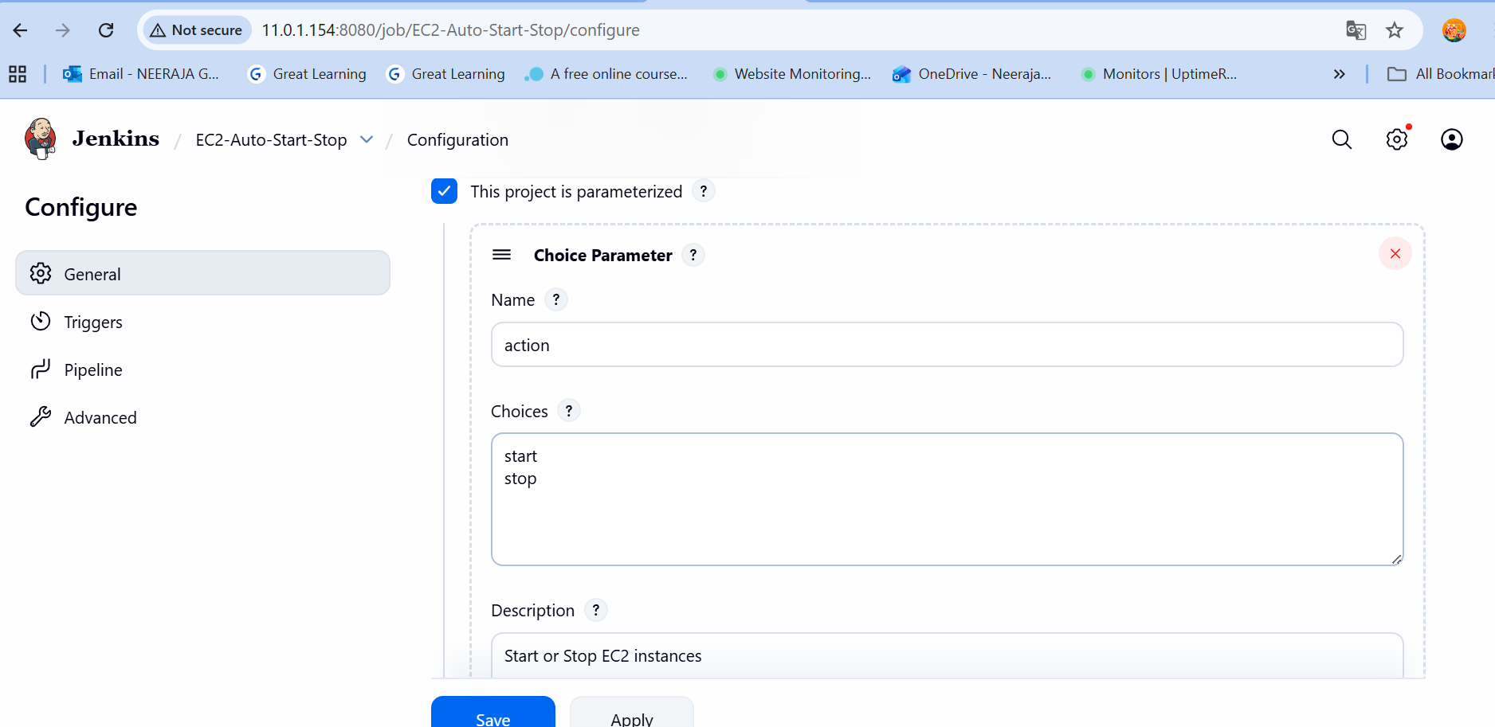
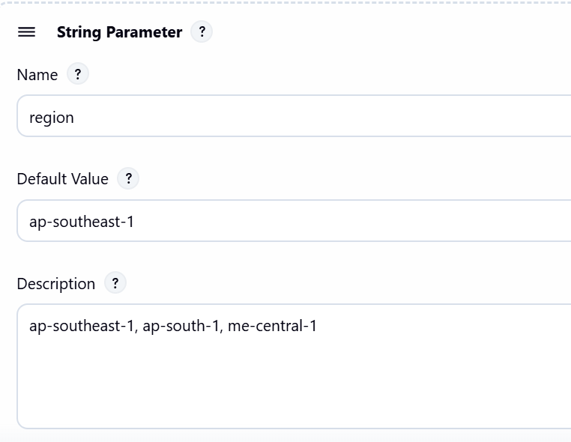
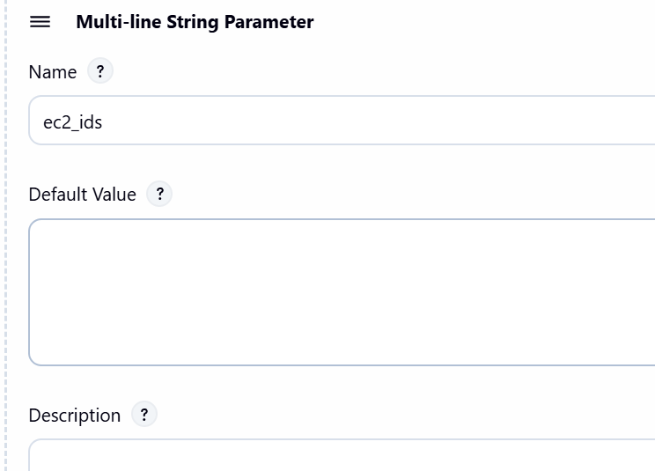
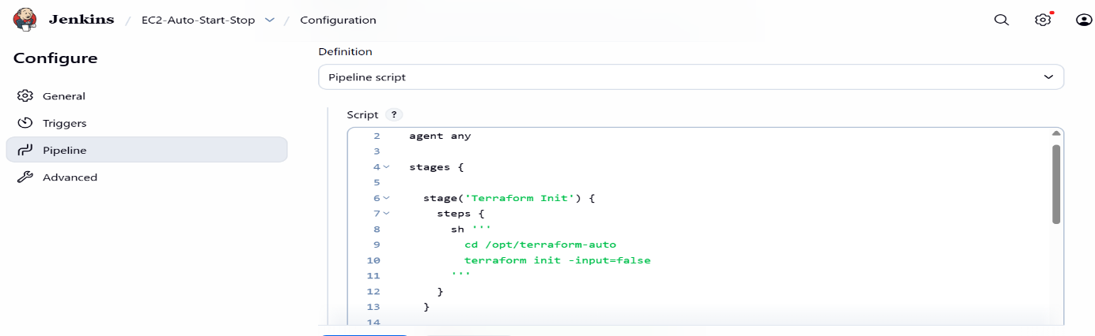

Got you. Here’s exact, click-by-click in Jenkins’ classic UI to add parameters to a Pipeline job.
Add parameters (classic UI)
- Open your job
- Jenkins Dashboard → click your job (e.g., EC2-Auto-Start-Stop) → Configure (left menu).
- Enable parameters
- In the General section (top of the page), tick This project is parameterized.
- A new row Add Parameter ▾ appears.
- Add action (Choice)
- Click Add Parameter ▾ → Choice Parameter.
- Name: action
- Choices: (each on its own line)
- start
- stop
- Description (optional): Start or Stop EC2 instances.
- Add region (String)
- Click Add Parameter ▾ → String Parameter.
- Name: region
- Default Value: ap-south-1
- Description (optional): AWS region (e.g., ap-south-1, me-central-1).
- Add ec2_ids (Multi-line String, optional)
- Click Add Parameter ▾ → Multi-line String Parameter.
- Name: ec2_ids
- Default Value: (leave empty to use your .auto.tfvars.json)
- Description: Optional. Paste one EC2 ID per line to override the default list.
- Save
- Scroll down → Save.
That’s it. You’ll now see Build with Parameters for this job.
-----------------jenkins job-------------------
pipeline {
agent any

stages {
stage('Terraform Init') {
steps {
sh '''
cd /opt/terraform-auto
terraform init -input=false
'''
}
}

stage('Terraform Plan') {
steps {
script {
def ec2List = ""

// Priority 1: use manual list if provided
if (params.ec2_ids?.trim()) {
ec2List = params.ec2_ids.trim().split(/[\\r\\n]+/).collect { "\"${it.trim()}\"" }.join(",")
}
// Priority 2: use dropdown if selected
else if (params.ec2_select?.trim()) {
def matches = params.ec2_select.findAll(/i-[0-9a-fA-F]+/)
ec2List = matches.collect { "\"${it}\"" }.join(",")
}

if (!ec2List) {
error "No EC2 IDs selected or provided — stopping build safely."
}

echo " Selected EC2s: ${ec2List}"

// Escaping fix (safe)
sh """
cd /opt/terraform-auto
terraform plan \\
-var="region=${params.region}" \\
-var="action=${params.action}" \\
-var='ec2_ids=["${ec2List.replaceAll("\"", "").replaceAll("\\s", "")}"]'
"""
}
}
}
}
}
-- It will use UI parameters
-- It will use staging tfvars automatically if ec2_ids empty
Save and build with parameters done success.
1️⃣ Your Jenkins Parameters (Keep these)
Parameter | Type | Example Value | Purpose
action | Choice | start / stop | what to do
region | Choice | ap-south-1, ap-southeast-1, me-central-1 | choose region
environment | Choice | non-prod, staging, uat | filter EC2s by tag
ec2_ids | Multi-line String | (optional) | manual override (optional)

--------------------------------------------------------------------------------------------------------------

Error: reading EC2 VPCs: operation error EC2: DescribeVpcs, https response error StatusCode: 403, RequestID: 8ab53813-8a52-4dce-a57a-d3f25df39e06, api error UnauthorizedOperation: You are not authorized to perform this operation. User: arn:aws:sts::107454851941:assumed-role/ec2_rds/i-039ae7c78a4ec156e is not authorized to perform: ec2:DescribeVpcs because no identity-based policy allows the ec2:DescribeVpcs action
│
│ with data.aws_vpcs.mumbai_vpcs,
│ on data_mumbai.tf line 3, in data "aws_vpcs" "mumbai_vpcs":
│ 3: data "aws_vpcs" "mumbai_vpcs" {
│
╵
╷
│ Error: reading EC2 Subnets: operation error EC2: DescribeSubnets, https response error StatusCode: 403, RequestID: fef972ac-23d7-467b-8c88-3ee7a6e994fa, api error UnauthorizedOperation: You are not authorized to perform this operation. User: arn:aws:sts::107454851941:assumed-role/ec2_rds/i-039ae7c78a4ec156e is not authorized to perform: ec2:DescribeSubnets because no identity-based policy allows the ec2:DescribeSubnets action
│
│ with data.aws_subnets.mumbai_subnets,
│ on data_mumbai.tf line 7, in data "aws_subnets" "mumbai_subnets":
│ 7: data "aws_subnets" "mumbai_subnets" {
│
╵
╷
│ Error: reading EC2 Security Groups: operation error EC2: DescribeSecurityGroups, https response error StatusCode: 403, RequestID: 25336aa0-bd09-4414-b351-26fd9e8384b9, api error UnauthorizedOperation: You are not authorized to perform this operation. User: arn:aws:sts::107454851941:assumed-role/ec2_rds/i-039ae7c78a4ec156e is not authorized to perform: ec2:DescribeSecurityGroups because no identity-based policy allows the ec2:DescribeSecurityGroups action
│
│ with data.aws_security_groups.mumbai_sgs,
│ on data_mumbai.tf line 15, in data "aws_security_groups" "mumbai_sgs":
│ 15: data "aws_security_groups" "mumbai_sgs" {
│
╵
╷
│ Error: reading RDS DB Instances: operation error RDS: DescribeDBInstances, https response error StatusCode: 403, RequestID: 35da06be-cfc9-4bce-93ff-ecc8e422f163, api error AccessDenied: User: arn:aws:sts::107454851941:assumed-role/ec2_rds/i-039ae7c78a4ec156e is not authorized to perform: rds:DescribeDBInstances on resource: arn:aws:rds:ap-south-1:107454851941:db:* because no identity-based policy allows the rds:DescribeDBInstances action
│
│ with data.aws_db_instances.mumbai_rds,
│ on data_mumbai.tf line 19, in data "aws_db_instances" "mumbai_rds":
│ 19: data "aws_db_instances" "mumbai_rds" {
│
╵
╷
│ Error: reading EC2 VPCs: operation error EC2: DescribeVpcs, https response error StatusCode: 403, RequestID: ef9531cb-a9f8-4fbe-a391-8d3cdb4bfc5e, api error UnauthorizedOperation: You are not authorized to perform this operation. User: arn:aws:sts::107454851941:assumed-role/ec2_rds/i-039ae7c78a4ec156e is not authorized to perform: ec2:DescribeVpcs because no identity-based policy allows the ec2:DescribeVpcs action
│
│ with data.aws_vpcs.sg_vpcs,
│ on data_singapore.tf line 3, in data "aws_vpcs" "sg_vpcs":
│ 3: data "aws_vpcs" "sg_vpcs" {}
│
╵
╷
│ Error: reading EC2 Subnets: operation error EC2: DescribeSubnets, https response error StatusCode: 403, RequestID: b02b3f37-00de-4d36-8a3b-7c0532ec0222, api error UnauthorizedOperation: You are not authorized to perform this operation. User: arn:aws:sts::107454851941:assumed-role/ec2_rds/i-039ae7c78a4ec156e is not authorized to perform: ec2:DescribeSubnets because no identity-based policy allows the ec2:DescribeSubnets action
│
│ with data.aws_subnets.sg_subnets,
│ on data_singapore.tf line 5, in data "aws_subnets" "sg_subnets":
│ 5: data "aws_subnets" "sg_subnets" {}
│
╵
╷
│ Error: reading EC2 Security Groups: operation error EC2: DescribeSecurityGroups, https response error StatusCode: 403, RequestID: 53ed9e95-4fb8-4468-b9ce-e15cb87a2af2, api error UnauthorizedOperation: You are not authorized to perform this operation. User: arn:aws:sts::107454851941:assumed-role/ec2_rds/i-039ae7c78a4ec156e is not authorized to perform: ec2:DescribeSecurityGroups because no identity-based policy allows the ec2:DescribeSecurityGroups action
│
│ with data.aws_security_groups.sg_sgs,
│ on data_singapore.tf line 9, in data "aws_security_groups" "sg_sgs":
│ 9: data "aws_security_groups" "sg_sgs" {}
│
╵
╷
│ Error: reading RDS DB Instances: operation error RDS: DescribeDBInstances, https response error StatusCode: 403, RequestID: 5675f361-6b8e-4711-b908-0832e93461dd, api error AccessDenied: User: arn:aws:sts::107454851941:assumed-role/ec2_rds/i-039ae7c78a4ec156e is not authorized to perform: rds:DescribeDBInstances on resource: arn:aws:rds:ap-southeast-1:107454851941:db:* because no identity-based policy allows the rds:DescribeDBInstances action
│
│ with data.aws_db_instances.sg_rds,
│ on data_singapore.tf line 11, in data "aws_db_instances" "sg_rds":
│ 11: data "aws_db_instances" "sg_rds" {}
│
╵
╷
│ Error: reading EC2 VPCs: operation error EC2: DescribeVpcs, https response error StatusCode: 403, RequestID: 1975fb08-6601-48c6-a33d-0a33824f1ce4, api error UnauthorizedOperation: You are not authorized to perform this operation. User: arn:aws:sts::107454851941:assumed-role/ec2_rds/i-039ae7c78a4ec156e is not authorized to perform: ec2:DescribeVpcs because no identity-based policy allows the ec2:DescribeVpcs action
│
│ with data.aws_vpcs.uae_vpcs,
│ on data_uae.tf line 3, in data "aws_vpcs" "uae_vpcs":
│ 3: data "aws_vpcs" "uae_vpcs" {
│
╵
╷
│ Error: reading EC2 Subnets: operation error EC2: DescribeSubnets, https response error StatusCode: 403, RequestID: a9111776-47f3-43de-8423-fde0b3b3d6c8, api error UnauthorizedOperation: You are not authorized to perform this operation. User: arn:aws:sts::107454851941:assumed-role/ec2_rds/i-039ae7c78a4ec156e is not authorized to perform: ec2:DescribeSubnets because no identity-based policy allows the ec2:DescribeSubnets action
│
│ with data.aws_subnets.uae_subnets,
│ on data_uae.tf line 7, in data "aws_subnets" "uae_subnets":
│ 7: data "aws_subnets" "uae_subnets" {
│
╵
╷
│ Error: reading EC2 Security Groups: operation error EC2: DescribeSecurityGroups, https response error StatusCode: 403, RequestID: 82fe8cfe-4132-418a-877d-08d48ec2d4e4, api error UnauthorizedOperation: You are not authorized to perform this operation. User: arn:aws:sts::107454851941:assumed-role/ec2_rds/i-039ae7c78a4ec156e is not authorized to perform: ec2:DescribeSecurityGroups because no identity-based policy allows the ec2:DescribeSecurityGroups action
│
│ with data.aws_security_groups.uae_sgs,
│ on data_uae.tf line 15, in data "aws_security_groups" "uae_sgs":
│ 15: data "aws_security_groups" "uae_sgs" {
│
╵
╷
│ Error: reading RDS DB Instances: operation error RDS: DescribeDBInstances, https response error StatusCode: 403, RequestID: 7e7bd013-de00-462c-b07c-46ac5bbd4cb8, api error AccessDenied: User: arn:aws:sts::107454851941:assumed-role/ec2_rds/i-039ae7c78a4ec156e is not authorized to perform: rds:DescribeDBInstances on resource: arn:aws:rds:me-central-1:107454851941:db:* because no identity-based policy allows the rds:DescribeDBInstances action
│
│ with data.aws_db_instances.uae_rds,
│ on data_uae.tf line 19, in data "aws_db_instances" "uae_rds":
│ 19: data "aws_db_instances" "uae_rds" {
│

